Project Design Phase Problem – Solution Fit Template

Date | 27 JUNE 2025
Team ID | NM2025TMID09058
Project Name | OPTIMIZING USER, GROUP, AND ROLE MANAGEMENT THROUGH ACCESS CONTROL AND WORKFLOWS
Maximum Marks | 2 Marks

Problem – Solution Fit

In many organizations, managing users, groups, and roles is often a manual and inefficient process. Administrators must individually assign permissions, approve access requests, and track changes — which leads to inconsistencies, human errors, and security risks. The absence of automated workflows also causes delays in approvals and makes it difficult to ensure proper access control across systems.

The solution to this problem is to implement an automated access control and workflow-based user management system. This system streamlines the process of assigning roles, managing group memberships, and controlling access permissions. By using predefined rules and approval workflows, organizations can ensure that the right users have the right access at the right time — improving security, operational efficiency, and accountability.

Purpose

To simplify and automate complex user, group, and role management tasks through structured access controls and approval workflows.

To improve operational efficiency and reduce manual errors by implementing automated processes that align with organizational needs and user behavior.

To enhance system security and compliance by ensuring consistent and rule-based access to sensitive data and resources.

To increase user satisfaction and trust by providing a transparent and efficient mechanism for access requests and approvals.

To understand the existing access management challenges and design a workflow-driven solution that improves security, accountability, and performance for all stakeholders

Template:

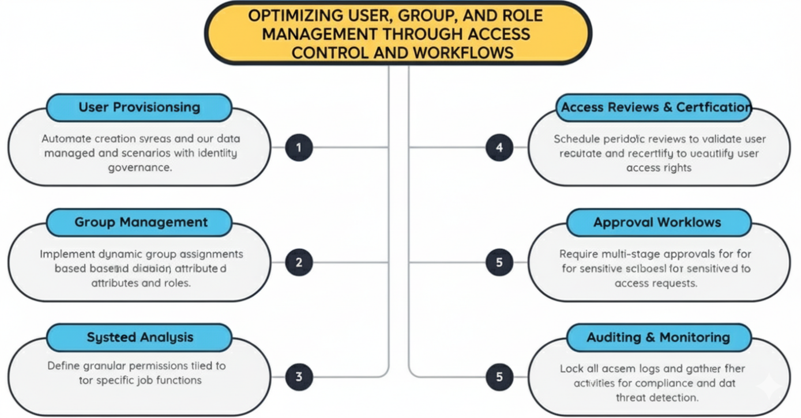

References:
- https://www.ideahackers.network/problem-solution-fit-canvas/
- https://medium.com/@epicantus/problem-solution-fit-canvas-aa3dd59cb4fe

Project Overview
The project “Optimizing User, Group, and Role Management through Access Control and Workflows” focuses on improving the efficiency, security, and accuracy of administrative operations within an organization. In many systems, user and role assignments are handled manually, which increases the chances of mismanagement, unauthorized access, and operational delays.
This project aims to implement automated access controls and approval workflows that streamline the process of assigning, modifying, and revoking user roles and permissions. By enforcing rule-based checks, predefined approval hierarchies, and continuous monitoring, the system ensures that access rights are granted securely and in alignment with organizational policies.
The solution enhances data security, accountability, and compliance, while also reducing the burden on IT administrators. Ultimately, this project lays the foundation for a more secure, transparent, and efficient role-based access management system within enterprise environments.

